A Visible Hero at Last
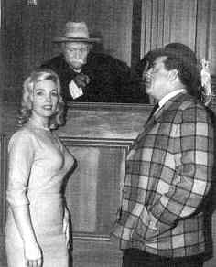
Disorder in the court. No, this is not a scene from one of Hamilton Burger's nightmares. It's actually a skit spoof on "Perry Mason" that appeared on "The Red Skelton Hour" in 1964. That's Julie Redding being judged by Red and defended by Raymond Burr. Courtesy of Capital Newspapers

